**CHINOOK INTEGRATION USING TALEND**

Microsoft PowerBI – create tabular reports and data visualizations for each query

1.Total sales

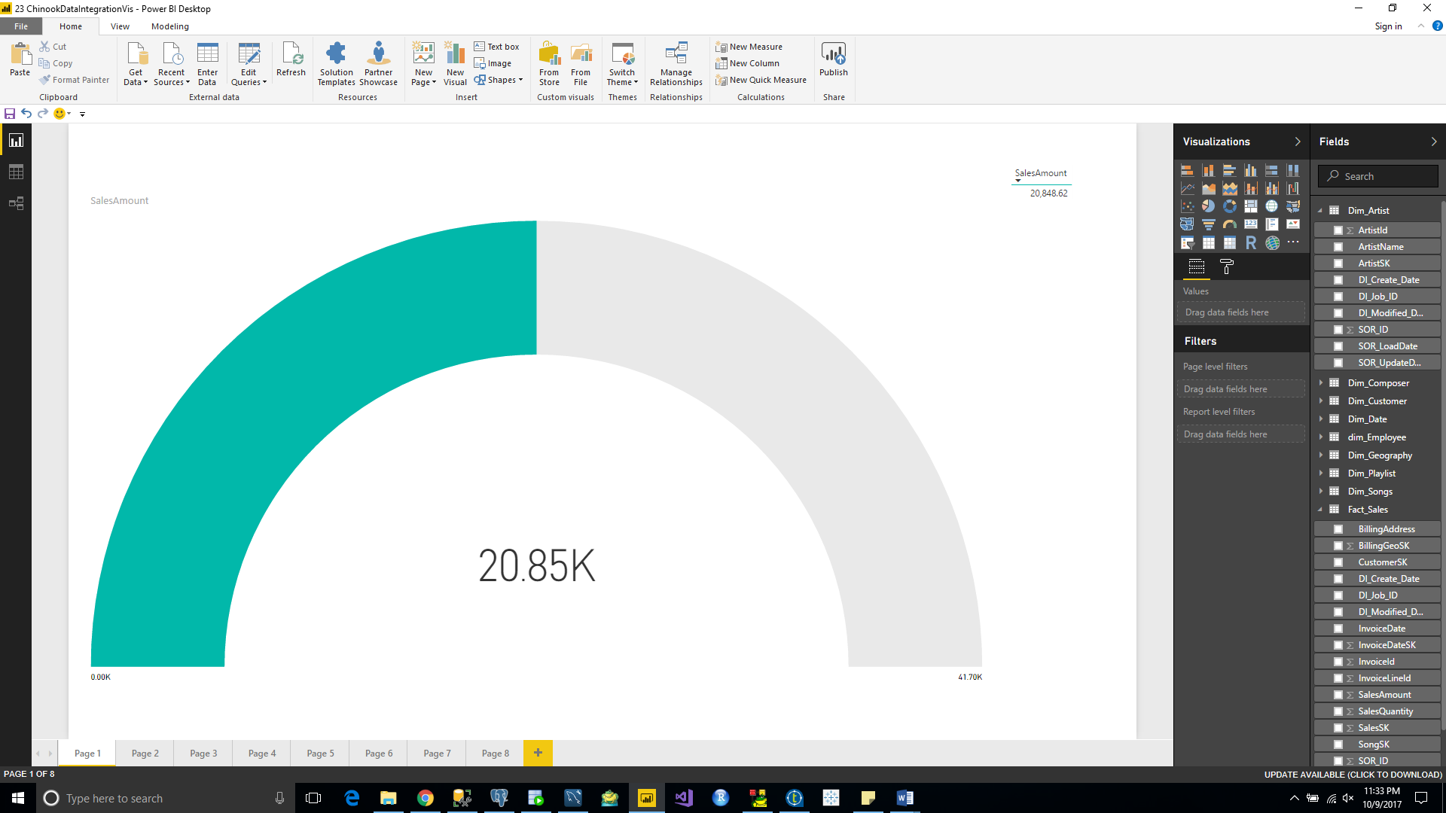

2.Total sales by country – ranked

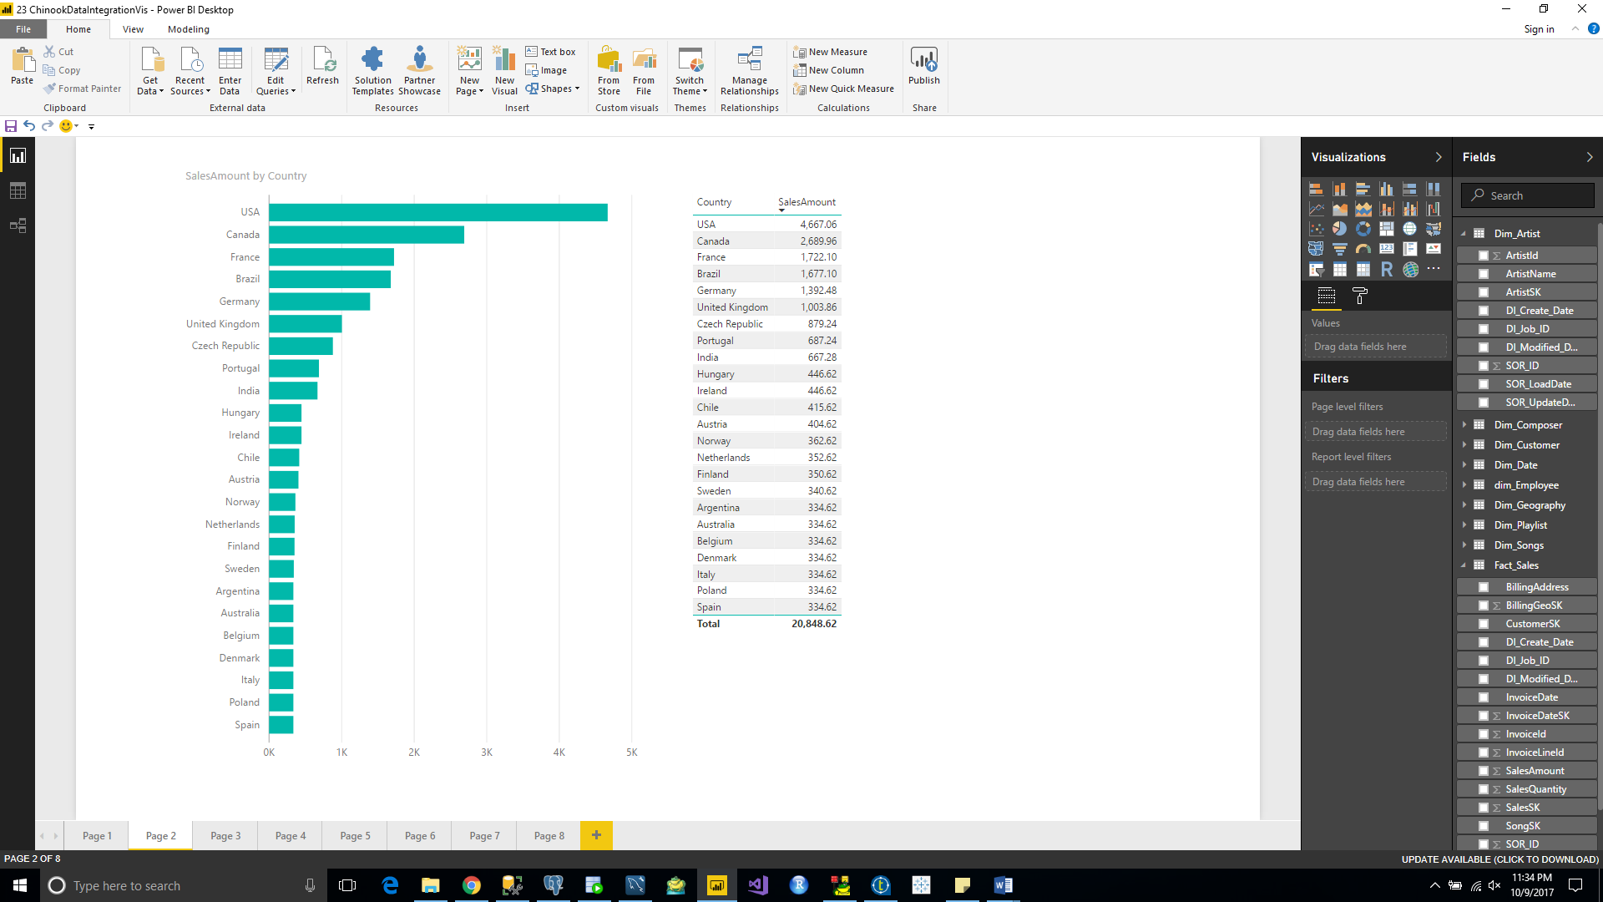

3.Total sales by country, state & city

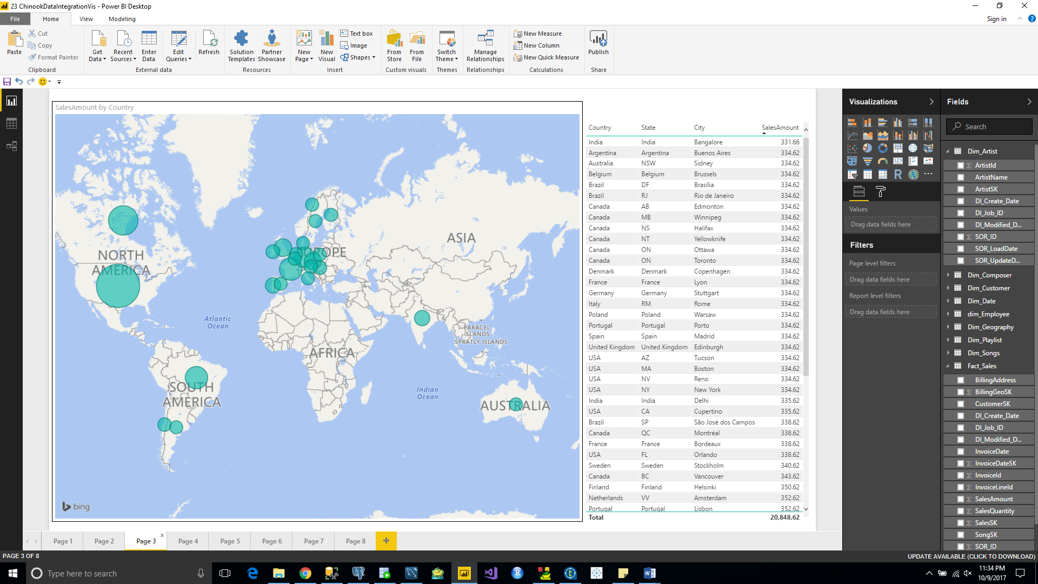

4.Total sales by customer – ranked

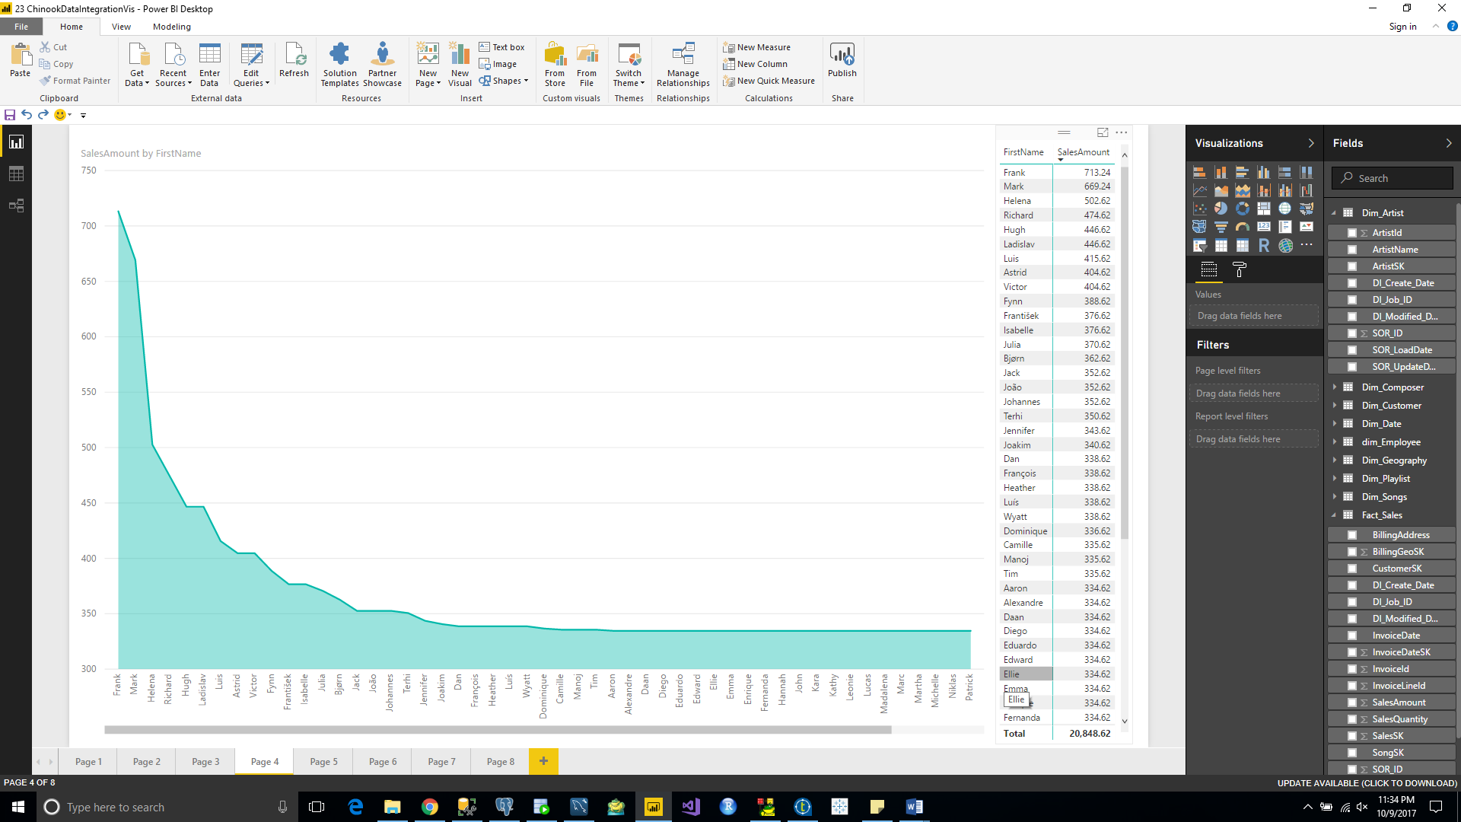

5.Total sales by artist – ranked

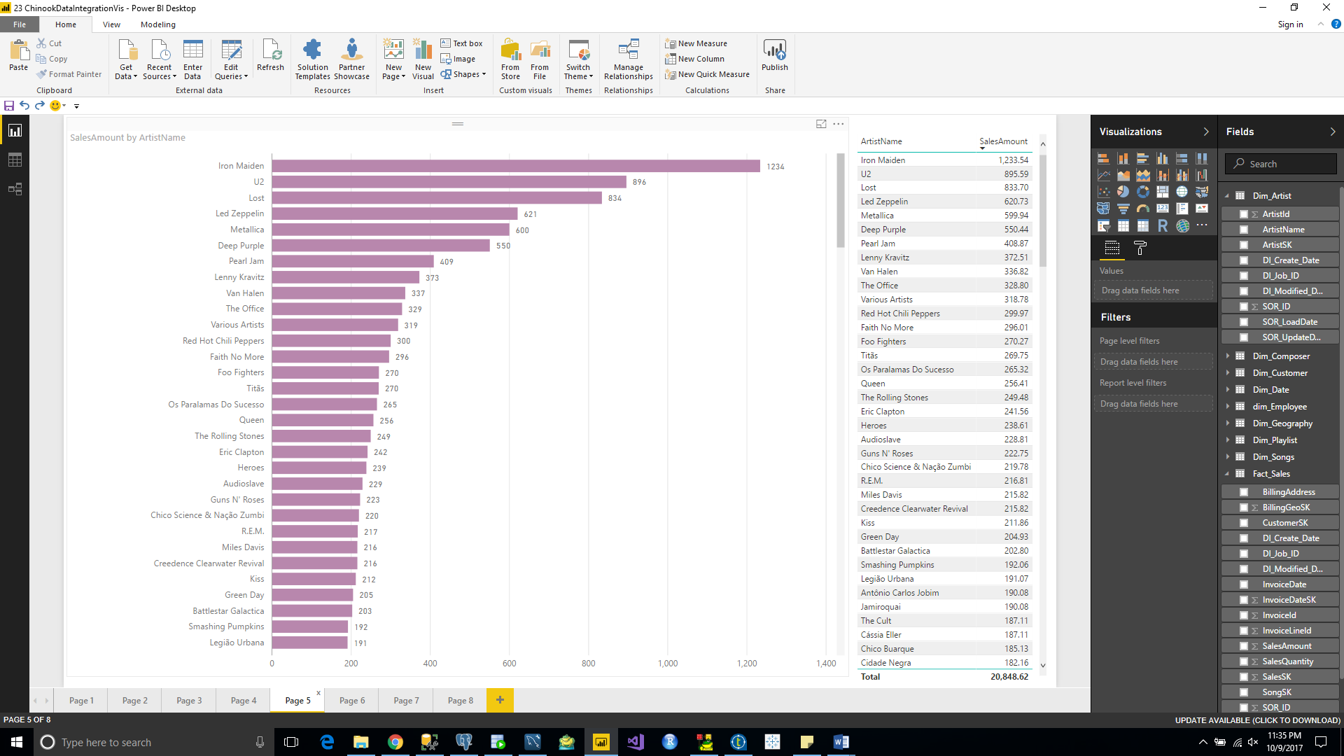

6.Total sales by artist & their albums

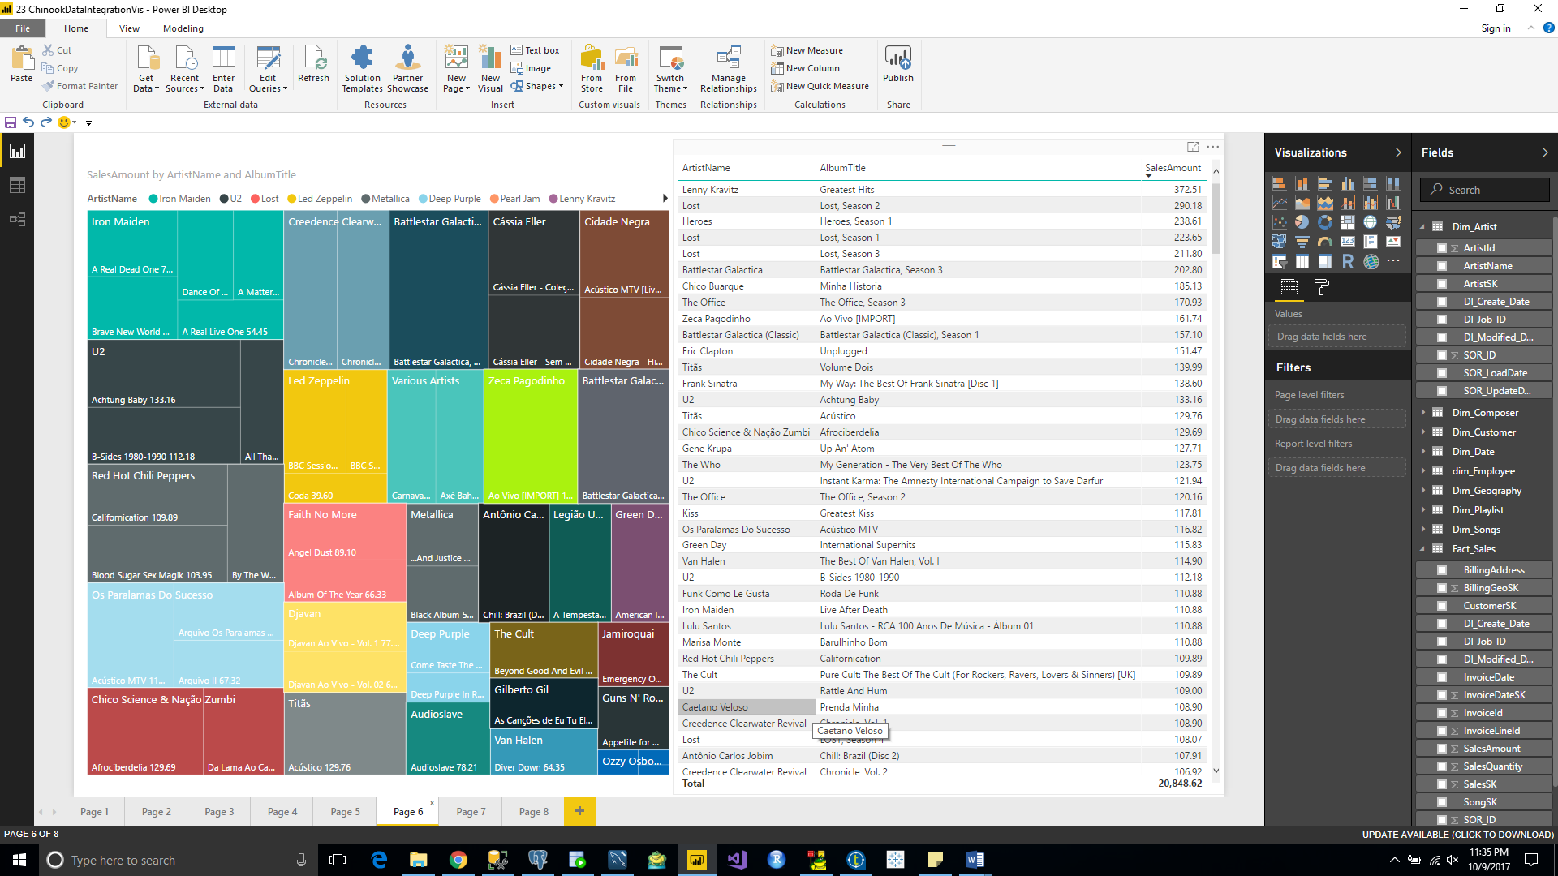

7.Total sales by sales person (employee)

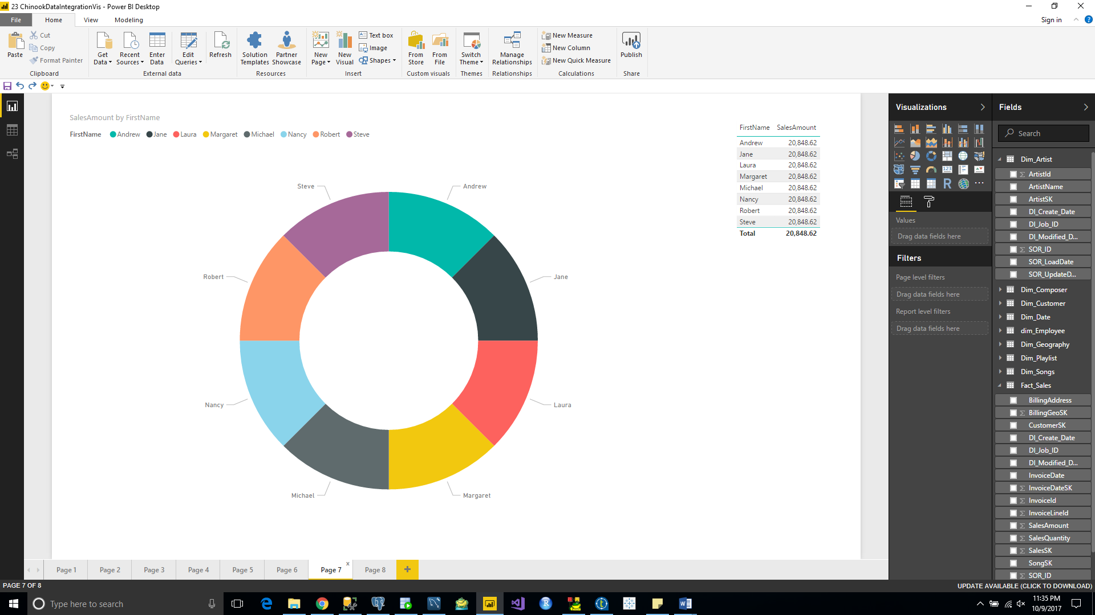

8.Total tracks bought and total cost by media type

